Servicing Spread Model

After the construction for the current coupon rate $C_{t}$ and $\hat{C_{t}}$, we need to have a review of the mortgage rate model framework:
$$\hat{M_{t}}= \hat{C_{t}}+ α^{t}∙\left(C_{0}- \hat{C_{0}}\right)+\hat{S_{t}}+ β^{t}∙(S_{0}- \hat{S_{0}})$$
In which, we already have the actual current coupon rate $C_{t}$through the historic current coupon calculation process using linear interpolation based on TBA settlement prices. And we also have the model current coupon rate $C_{t}$calculated by the linear current coupon model:
$$\hat{C_{t}}= α_{0}+ α_{1}{Swap2}_{t}+ α_{2}{Swap10}_{t}+ α_{t}{SwapVol}_{t}$$
Next, we should focus on the servicing spread model $S_{t}$ and $\hat{S_{t}}$, as well as the decay factor $α^{t}$ and $β^{t}$.

- Actual servicing spread $S_{t}$
In our current implementation, we use an assumption that the servicing spread is the difference between the mortgage rate and the current coupon rate:
$$S_{t}= Mortgage Rate-Current Coupon$$
$$= Mortgage Rate- C_{t}$$
As discussed in Section 2 and 3 of the Modeling Framework paper, we use the Primary Fixed Rate as the actual mortgage rate. The Primary Fixed Rate is published every Thursday, and is the backward average for the previous week. Here, we keep the published average rate for the previous week and back fill the daily data points from this weekly data set.
After calculation, we get the actual servicing spread as below:
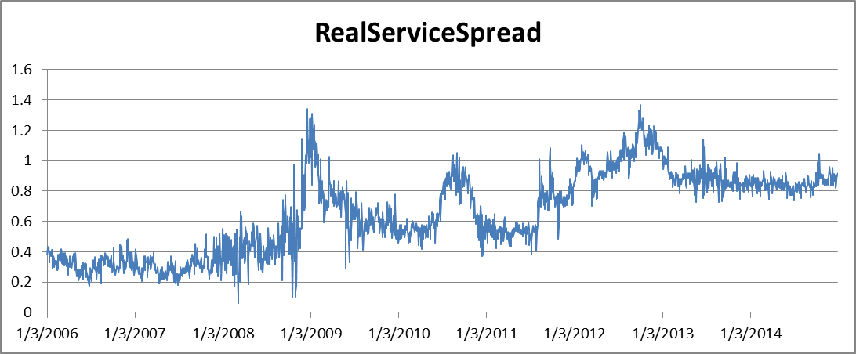

- Servicing Spread Model $\hat{S_{t}}$
As discussed in Section 5 of the paper, for our current servicing spread model, we assume that $\hat{S_{t}}$ to be a constant, $\hat{S_{t}}=x bps$. This constant can be estimated by the average of the historic servicing spread. From the data set from Jan 2006 to Dec 2014, we have an average servicing spread of 65 bps.
$$\hat{S_{t}}=65 bps$$
Through as we can see from the picture above, the servicing spread grows up from around 35 bps in 2006 to 85 bps in 2014, for the reason that we need to project the data for 30 years ahead, it is not inadequate to ignore this trend and to use the nine years average.

- Decay Factor $α^{t}$ and $β^{t}$
Since the purpose of introducing these two decay factors is to adjust the model estimation differently through the projection period. So an initial thought might be using some technic to minimize the tracking error between actual and model value. As we have two factors need to optimize, some optimization method might be good for this case.
One suggestion is GNU Scientific Library optimization routines, which allows us to choose some criteria, like least square, based on a multi-variable case, and minimize the optimization error.

